UniPact V1.0 Wireframes & Data Contracts

Document Date: 14/12/2025
This document outlines the low-fidelity wireframes and the implied data requirements for the key pages of the UniPact platform. This serves as the blueprint for both front-end and back-end development.

1. The "Split" Registration Landing Page
(Path: /register)
User Goal: Identify which side of the marketplace they belong to.
Design Strategy: Do not show a form immediately. Show a clear choice with value propositions to reduce bounce rates
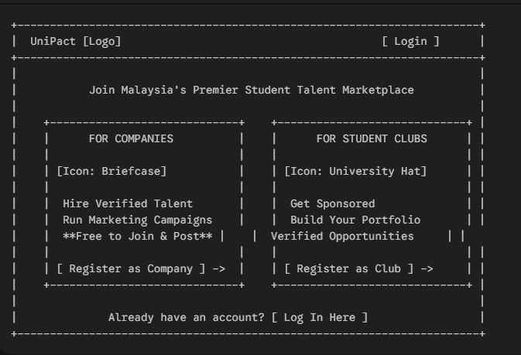

2. Company Registration Form
(Path: /register/company)
Critical Requirement: This form creates the User and the CompanyProfile. It sets tier_status = 'free' by default (per SRS v2.1).
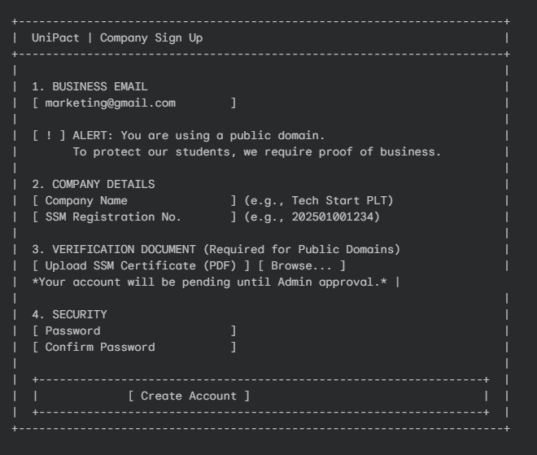
2.1 Data Contract (POST /api/auth/register/company):
- email: String
- company_name: String
- ssm_number: String (New)
- ssm_document: File (Required if is_public_domain(email) is True)

3. Student Club Registration Form
(Path: /register/club)
Critical Requirement: This form must manage expectations. It creates a ClubProfile with verification_status = 'pending'. The UI must warn them that they cannot apply instantly
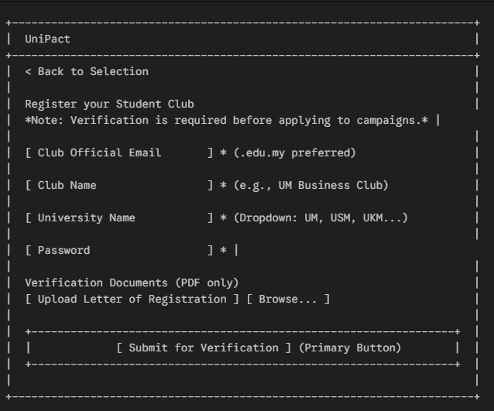

3.1 Data Contract (API Request):
- Endpoint: POST /api/auth/register (Multipart/Form-Data)
- Payload:
  - role: "club"
  - email: "pres@um-business.edu.my"
  - password: "..."
  - club_name: "UM Business Club"
  - university: "Universiti Malaya"
  - verification_doc: [File Object]

4. Universal Login Page
(Path: /login)
Design Strategy: Keep it simple. The backend handles routing.
- If Company logs in -> Go to /dashboard
- If Club logs in -> Go to /club/home
- If Admin logs in -> Go to /admin/overview
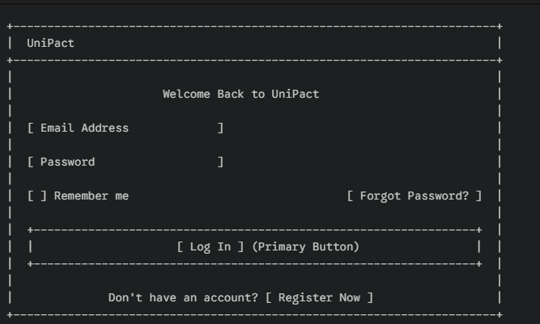

4.1 Data Contract (API Request):
- Endpoint: POST /api/auth/login
- Payload: { "email": "...", "password": "..." }
- Response (Success 200):
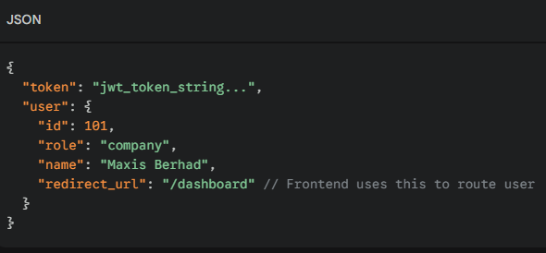

5.Company Dashboard
(Path: company/dashboard)
User Goal: "As a Company User, I want to see a high-level overview of my active campaigns and any pending applications so I can manage my projects."
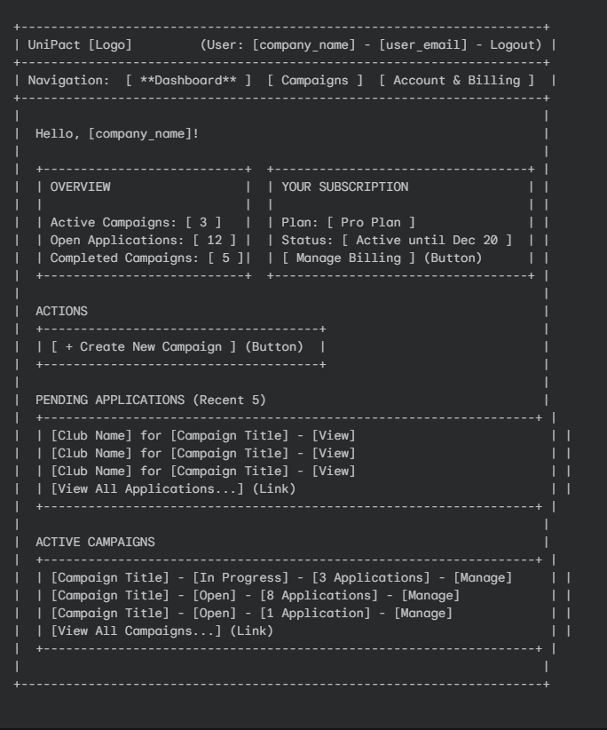

5.1 - Data Contract (API Blueprint)
This page will be powered by a single API endpoint: GET /api/dashboard
This endpoint MUST return a JSON object with all the data needed to render this page, which includes:
- company_name
- subscription_status (e.g., "Pro Plan", "Active until Dec 20")
- overview_stats:
  - active_campaign_count
  - open_application_count
  - completed_campaign_count
- pending_applications (Array, limit 5)
  - club_name
  - campaign_title
  - application_id (for the link)
- active_campaigns (Array, limit 3)
  - campaign_title
  - campaign_status (e.g., 'open', 'in_progress')
  - application_count
  - campaign_id (for the link)

6.Create Campaign Form
(Path: /campaigns/new)
User Goal: "As a Company User, I want to fill out a simple form to post a new campaign."

6.1 - Wireframe (ASCII)
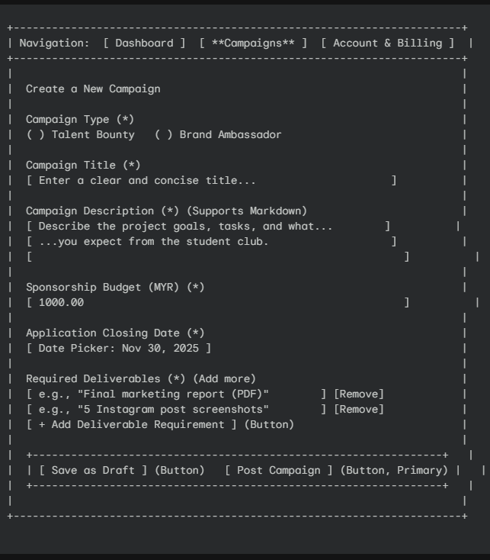

6.2 - Data Contract (API Blueprint)
This page is a form that submits data to a single API endpoint: POST /api/campaigns
The JSON request body sent to this endpoint MUST look like this:
{
"campaign_type": "talent_bounty",
"title": "New Marketing Strategy for Gen Z",
"description": "We need a new... (markdown text)",
"budget": "1000.00",
"closing_date": "2025-11-30T23:59:59Z",
"deliverable_requirements": [
"Final marketing report (PDF)",
"5 Instagram post screenshots"
],
"action": "post" // or "draft" if they click "Save as Draft"
}

- On Success (201 Created): The API should return the new campaign_id and the app should redirect to /campaigns/[new_id]/manage.
- On Failure (400 Bad Request): The API should return a JSON object of validation errors (e.g., {"budget": "This field must be a valid number."}).
- On Failure (403 Forbidden): The API should return this if the user's subscription doesn't allow them to post a new campaign (e.g., they are at their limit). This is a critical business rule from our sequence diagram.

7.Club Dashboard (The Command Center)
(Path: /club/dashboard)
User Goal: "As a Club President, I need to know if I'm verified, track my applications, and manage active projects."
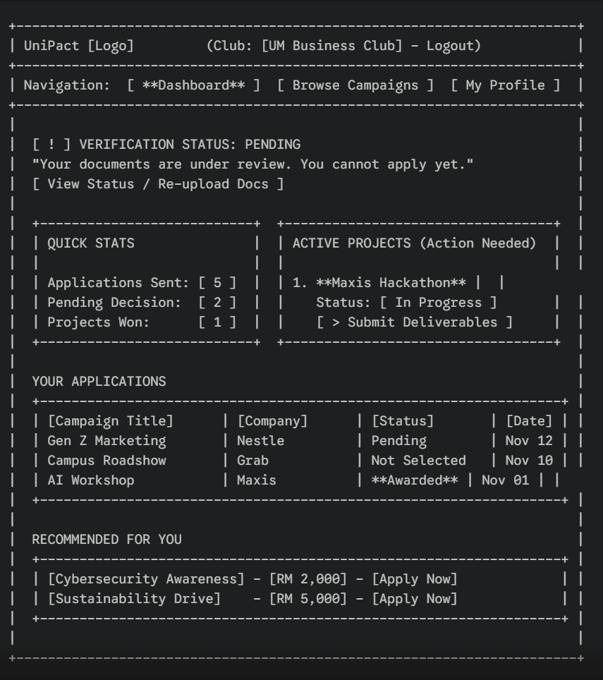

7.1 Data Contract (API)
- Endpoint: GET /api/club/dashboard
- Response:
  - verification_status: "pending" | "verified" | "rejected"
  - active_projects: Array (Campaigns with status 'in_progress')
  - applications: Array (Recent history)

8.Club Application Page ("Propose Services")
(Path: /campaigns/{id}/apply)
User Goal: "As a Club, I want to pitch my team to the Company so they hire us."
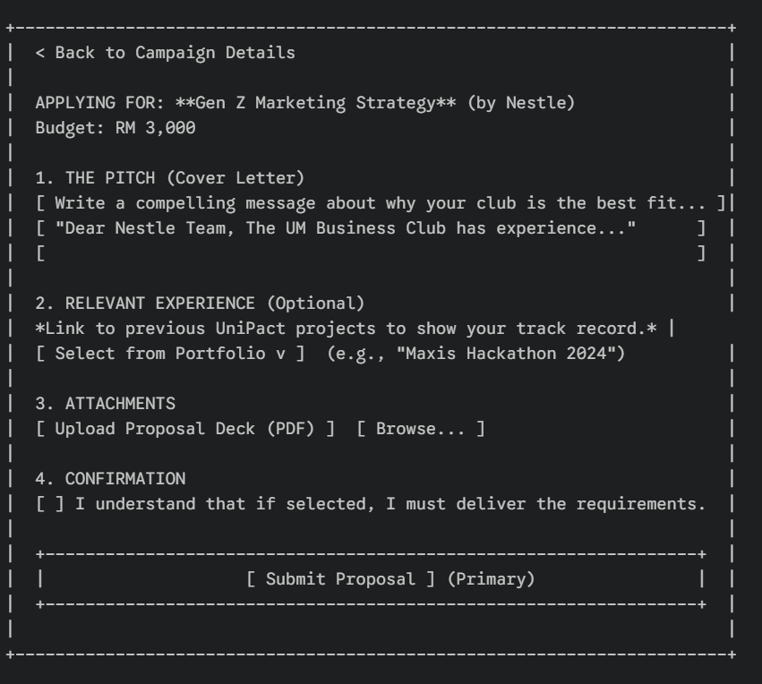

8.1 Data Contract (API)
- Endpoint: POST /api/campaigns/{id}/apply
- Payload:
  - cover_letter: Text
  - portfolio_links: Array (IDs of past reports)
  - proposal_doc: File
GET /api/club/portfolio
Response: [{ id: 101, title: "Maxis Hackathon", company: "Maxis" }, ...]

9.Wireframe Update: Club Dashboard (Roster Tab)
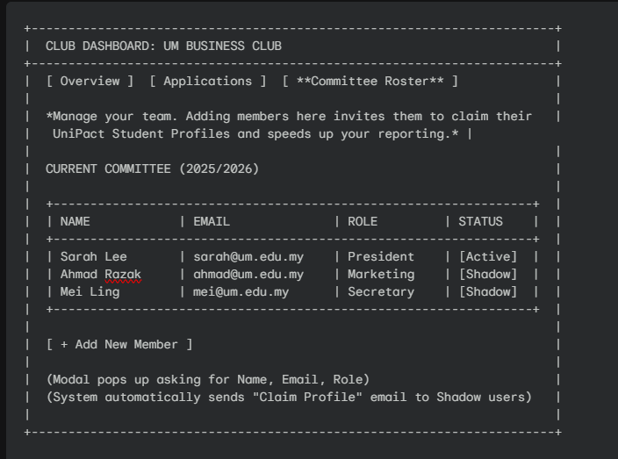
9.1 Data Contract (POST /api/club/roster):
- full_name: "Ahmad Razak"
- email: "ahmad@um.edu.my"
- role: "Marketing Head"
- Backend Logic: Triggers create_shadow_user(email) if user doesn't exist

10.Student Profile (The "Claimed" Portfolio)
Path: /student/{username}
User Goal: "As a student (Sarah), I want to show this link to a recruiter to prove I have real experience."
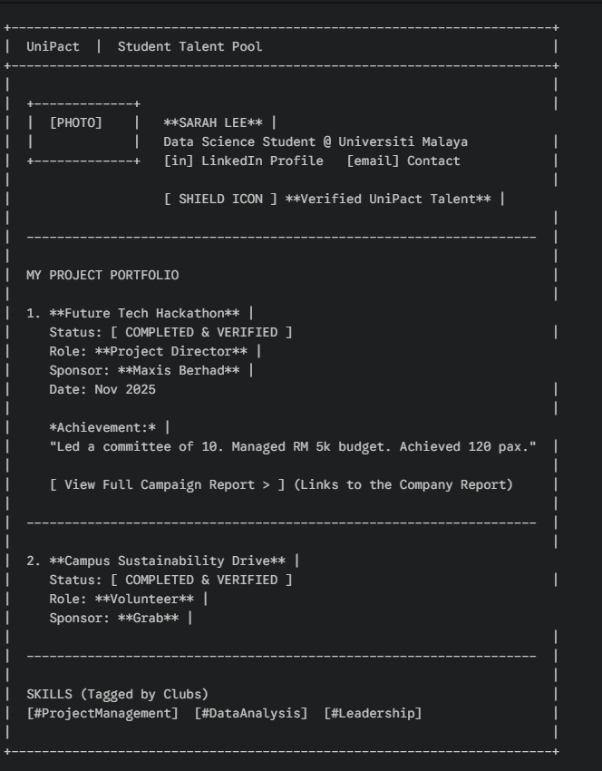

10.1Data Contract (API)
- Endpoint: GET /api/student/{id}
- Response:
  - student_info: Name, Uni, Photo
  - is_verified: Boolean (True if they claimed the account)
  - projects: Array
    - campaign_title
    - company_name
    - role (e.g., "Director")
    - campaign_report_id (Link to the proof)

11.Report Navigation Concept
Since this is a multi-page report, we need a consistent header. (Common Header for All Pages)
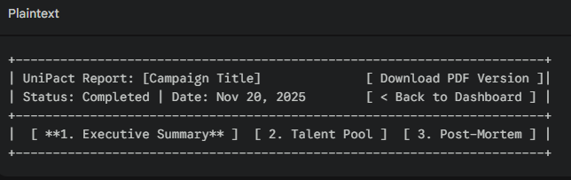

11.1Executive Summary
Goal: The "ROI" Page. Show the company exactly what their money bought.
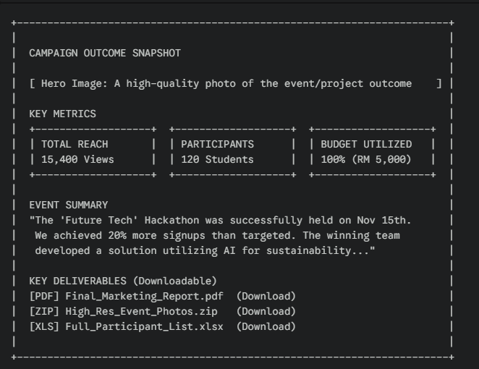

11.2Talent Pool (The "Headhunting" Page)
Goal: Separate the Organizers (Leadership talent) from the Winners (Skill talent).
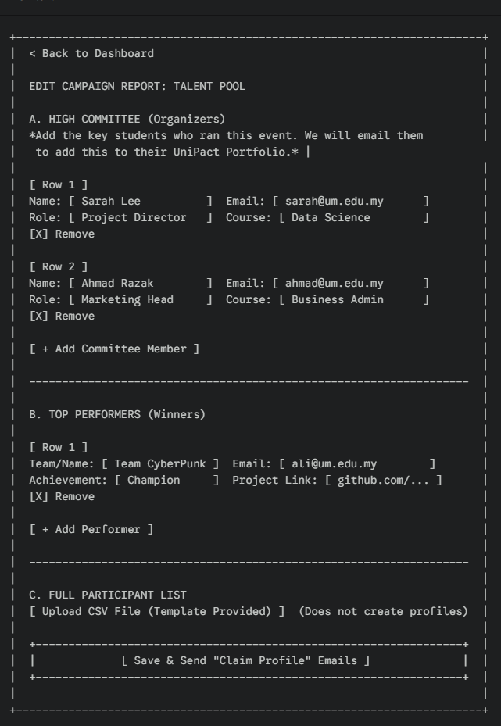

11.2.1 Sub-Page: Talent Profile Detail
Trigger: Clicking [View Profile] on the previous page.
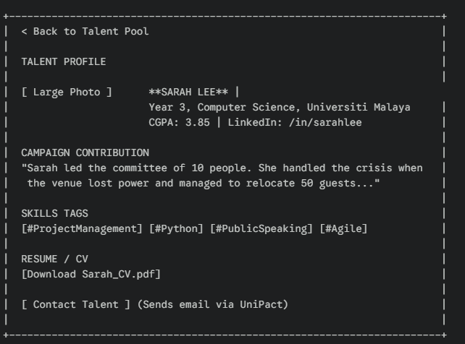

11.3 Post-Mortem & Feedback
Goal: Qualitative analysis. What went well? What went wrong?
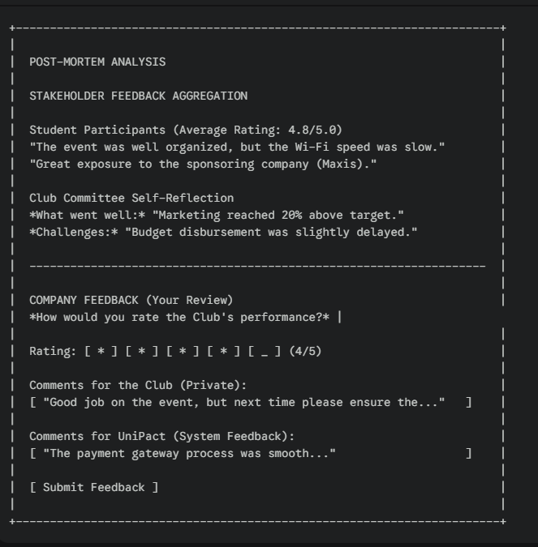

11.4 Data Contract (API Requirements)
To build these pages, your backend needs to serve a specific JSON structure. Endpoint: GET /api/reports/{campaign_id}
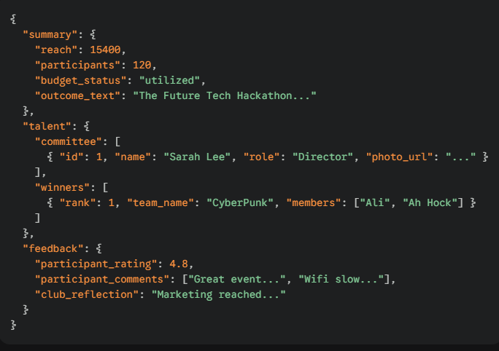

12.Wireframe Update: Admin Dashboard
Your Admin now needs a place to police these companies.
(Path: /admin/companies)

